What is React?
React is a front-end JavaScript library.
React was developed by the Facebook Software Engineer Jordan Walke.
React is also known as React.js or ReactJS.
React is a tool for building UI components.

How does React Work?
React creates a VIRTUAL DOM in memory.
Instead of manipulating the browser's DOM directly, React creates a virtual DOM in memory, where it does all the necessary manipulating, before making the changes in the browser DOM.
React only changes what needs to be changed!
React finds out what changes have been made, and changes only what needs to be changed.

Setting up a React Environment
First, make sure you have Node.js installed. You can check by running this in your terminal:
node -v
If Node.js is installed, you will get a result with the version number:
v22.15.0
If not, you will need to install Node.js.

Install a Build Tool (Vite)
When you have Node.js installed, you can start creating a React application by choosing a build tool.
We will use the Vite build tool in this tutorial.
Run this command to install Vite:
npm install -g create-vite
If the installation was a success, you will get a result like this:
added 1 package in 649ms

Create a React Application
Run this command to create a React application named my-react-app:
npm create vite@latest my-react-app -- --template react
If you get this message, just press y and press Enter to continue:
Need to install the following packages:
create-vite@9.0.7
Ok to proceed? (y)
Next, you might get this message, just press Enter to continue:

> npx
> create-vite my-react-app --template react

|
* Install with npm and start now?
| > Yes / No
-
If the creation was a success, you will get a result like this:
VITE v8.0.15 ready in 262 ms
→ Local: http://localhost:5173/
→ Network: use --host to expose
→ press h + enter to show help

A new browser window will pop up with your newly created React App! If not, open your browser and type localhost:5173 in the address bar.
The result:
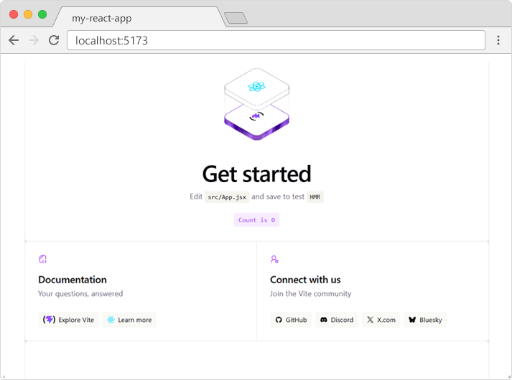

React Render HTML

React renders HTML to the web page via a container, and a function called createRoot().
To better understand the content of the index.html file, let's remove all the code we don't need.

Example
The index.html file should now look like this:
index.html
<!doctype html>
<html lang="en">
<body>
<div id="root"></div>
<script type="module" src="/src/main.jsx"></script>
</body>
</html>

The file is now stripped from unnecessary code, and we can concentrate on learning React without any disturbing elements.

The createRoot Function
The createRoot function is located in the main.jsx file in the src folder, and is a built-in function that is used to create a root node for a React application.

Example
The default content of the src/main.jsx file:
main.jsx
import { StrictMode } from 'react'
import { createRoot } from 'react-dom/client'
import './index.css'
import App from './App.jsx'

createRoot(document.getElementById('root')).render(
<StrictMode>
<App />
</StrictMode>
)

The createRoot() function takes one argument, an HTML element.
The purpose of the function is to define the HTML element where a React component should be displayed.
To better understand the createRoot function, let's remove unnecessary code and write our own "Hello React!" example:

Example
The src/main.jsx file should now look like this:
main.jsx
import { createRoot } from 'react-dom/client'

createRoot(document.getElementById('root')).render(
<h1>Hello React!</h1>
)

If you save the file, the result in the browser will look like this:
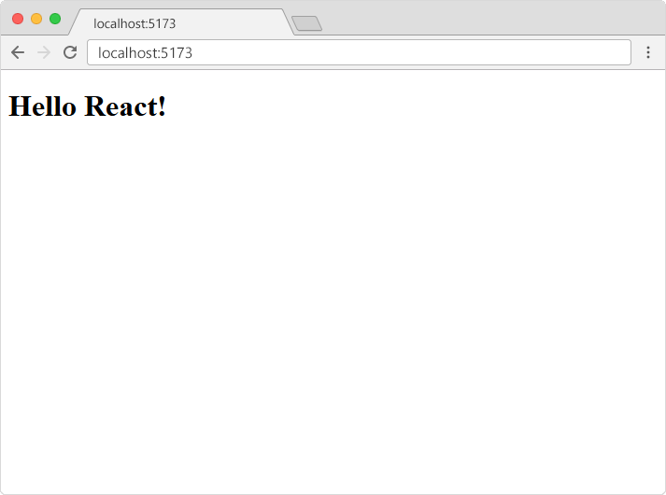

The render Method
The render method defines what to render in the HTML container.
The result is displayed in the <div id="root"> element.

Example
Display a paragraph inside the "root" element:
main.jsx
import { createRoot } from 'react-dom/client'

createRoot(document.getElementById('root')).render(
<p>Welcome!</p>
)

The result will look like this:
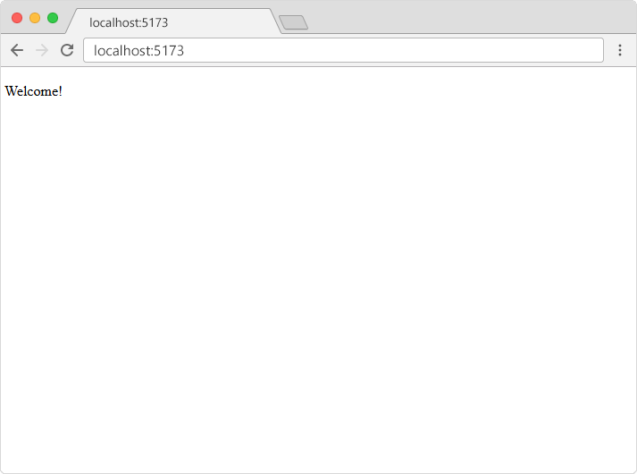

The Container
React uses a container to render HTML in a web page.
Typically, this container is a <div id="root"></div> element in the index.html file.

React ES6

What is ES6?
ES6 stands for ECMAScript 6.
ECMAScript was created to standardize JavaScript, and ES6 is the 6th version of ECMAScript, it was published in 2015, and is also known as ECMAScript 2015.

Why Should I Learn ES6?
React uses ES6, and you should be familiar with some of the new features like:
- Classes
- Arrow Functions
- Variables (let, const, var)
- Array Methods like .map()
- Destructuring
- Modules
- Ternary Operator
- Spread Operator
ES6 introduced classes.
A class is a type of function, but instead of using the keyword function to initiate it, we use the keyword class, and the properties are assigned inside a constructor() method.

A simple class constructor:
class Car {
constructor(name) {
this.brand = name;
}
}
Notice the case of the class name. We have begun the name, "Car", with an uppercase character. This is a standard naming convention for classes.
Now you can create objects using the Car class:

Example
Create an object called "mycar" based on the Car class:
class Car {
constructor(name) {
this.brand = name;
}
}

const mycar = new Car("Ford");
Note: The constructor function is called automatically when the object is initialized.

Method in Classes
You can add your own methods in a class:

Example
Create a method named "present":
class Car {
constructor(name) {
this.brand = name;
}

present() {
return 'I have a ' + this.brand;
}
}

const mycar = new Car("Ford");
mycar.present();
As you can see in the example above, you call the method by referring to the object's method name followed by parentheses (parameters would go inside the parentheses).

Class Inheritance
To create a class inheritance, use the extends keyword.
A class created with a class inheritance inherits all the methods from another class:

Example
Create a class named "Model" which will inherit the methods from the "Car" class:
class Car {
constructor(name) {
this.brand = name;
}

present() {
return 'I have a ' + this.brand;
}
}

class Model extends Car {
constructor(name, mod) {
super(name);
this.model = mod;
}
show() {
return this.present() + ', it is a ' + this.model
}
}
const mycar = new Model("Ford", "Mustang");
mycar.show();
The super() method refers to the parent class.
By calling the super() method in the constructor method, we call the parent's constructor method and get access to the parent's properties and methods.

Arrow Functions
Arrow functions allow us to write shorter function syntax:
hello = function() {
return "Hello World!";
}

Example
With Arrow Function:
hello = () => {
return "Hello World!";
}
It gets shorter! If the function has only one statement, and the statement returns a value, you can remove the brackets and the return keyword:

Example
Arrow Functions Return Value by Default:
hello = () => "Hello World!";
Note: This works only if the function has only one statement.
If you have parameters, you pass them inside the parentheses:

Example
Arrow Function With Parameters:
hello = (val) => "Hello " + val;
In fact, if you have only one parameter, you can skip the parentheses as well:

Example
Arrow Function Without Parentheses:
hello = val => "Hello " + val;

What About this?
The handling of this is also different in arrow functions compared to regular functions.
In short, with arrow functions there is no binding of this.
In regular functions the this keyword represented the object that called the function, which could be the window, the document, a button or whatever.
With arrow functions, the this keyword always represents the object that defined the arrow function.
Let us take a look at two examples to understand the difference.
Both examples call a method twice, first when the page loads, and once again when the user clicks a button.
The first example uses a regular function, and the second example uses an arrow function.
The result shows that the first example returns two different objects (window and button), and the second example returns the Header object twice.

Example
With a regular function, this represents the object that called the function//Arrow function:
changeColor = () => {
document.getElementById("demo").innerHTML += this;
}
}

const myheader = new Header();

//The window object calls the function:
window.addEventListener("load", myheader.changeColor);

//A button object calls the function:
document.getElementById("btn").addEventListener("click", myheader.changeColor);

React JSX

What is JSX?
JSX stands for JavaScript XML.
JSX allows us to write HTML in React.
JSX makes it easier to write and add HTML in React.

Coding JSX
JSX allows us to write HTML elements in JavaScript and place them in the DOM without any createElement() and/or appendChild() methods.
JSX converts HTML tags into react elements.

Example 1

JSX:
main.jsx
const myElement = <h1>I Love JSX!</h1>;

createRoot(document.getElementById('root')).render(
myElement
);
<!doctype html>
<html lang="en">
<body>
<div id="root"></div>
<script type="module" src="/src/main.jsx"></script>
</body>
</html>

Example 2
Without JSX:
main.jsx
import React from 'react';
import { createRoot, createElement } from 'react-dom/client'

const myElement = React.createElement('h1', {}, 'I do not use JSX!');

createRoot(document.getElementById('root')).render(
myElement
);

<!doctype html>
<html lang="en">
<body>
<div id="root"></div>
<script type="module" src="/src/main.jsx"></script>
</body>
</html>

React JSX Expressions

One of the most powerful features of JSX is the ability to embed JavaScript expressions directly within your markup.

Expressions
You can insert any valid JavaScript expression inside JSX by wrapping it in curly braces { }.
React will evaluate the expression and render the result in the DOM.
Execute the expression 218 * 1.36:
function Car() {
return (
<>
<h1>My car</h1>
<p>It has {218 * 1.36} horsepower</p>
</>
);
}

Variables
Variables are also valid expressions. Insert variables in JSX by wrapping it in curly braces { }.

Example
Use a variable inside JSX:
function Car() {
const hp = 218 * 1.36;
return (
<>
<h1>My car</h1>
<p>It has {hp} horsepower</p>
</>
);
}

Function Calls
Function calls are valid expressions. Insert function calls in JSX by wrapping it in curly braces { }.

Example
Use a function inside JSX:
function kwtohp(kw) {
return kw * 1.36;
}

function Car() {
return (
<>
<h1>My car</h1>
<p>It has {kwtohp(218)} horsepower</p>
</>
);
}

Object Properties
Access object properties within JSX:

Example
Refer to an object property inside JSX:
function Car() {
const myobj = {
name: "Fiat",
model: "500",
color: "white"
};
return (
<>
<h1>My car is a {myobj.color} {myobj.name} {myobj.model}</h1>
</>
);
}

React.js Installation and Execution in Visual Studio Code (Step-by-Step Guide)

Step 1: Install Node.js
React requires Node.js.
- Open your browser.
- Go to:
https://nodejs.org
- Download the LTS (Long Term Support) version.
- Install it using the default settings.
- Restart your computer if prompted.

Step 2: Verify Node.js Installation
Open Command Prompt or VS Code Terminal.
Type:
node -v
Example output:
v22.18.0
Check npm:
npm -v
Example output:
10.9.3
If both commands display version numbers, Node.js is installed correctly.

Step 3: Open Visual Studio Code
Open Visual Studio Code.

Step 4: Open a Terminal
Go to
Terminal → New Terminal
A terminal opens at the bottom.

Step 5: Create a React Project
Type: IF NO ERROR TYPE: npm create vite@latest
IF ERROR TYPE
npm.cmd create vite@latest
Press Enter.

Step 6: Enter Project Name
It asks:
Project name:
Example:
my-react-app
Press Enter.

Step 7: Select Framework
You will see:
Select a framework
○ Vanilla
○ Vue
❯ React
○ Preact
○ Lit
○ Svelte
Use the Arrow Keys.
Select
React
Press Enter.

Step 8: Select Variant
Next screen:
Select a variant
❯ JavaScript
TypeScript
Choose
JavaScript
Press Enter.

Step 9: Select Linter
Next screen:
Select a linter
❯ ESLint
Biome
None
Choose
ESLint
Press Enter.

Step 10: Move into the Project Folder
Suppose the project name is
my-react-app
Type
cd my-react-app

Step 11: Install Required Packages
Type
Npm.cmd install
Wait until installation completes.
Example:
added 152 packages

Step 12: Start the React Development Server
Type
Npm.cmd run dev
You will see:
VITE v7.x.x
Local:
http://localhost:5173/
Sometimes the port may be:
5174
5175
5176
Always open the exact URL shown in your terminal.

Step 13: Open the Browser
Open
http://localhost:5173/
(or whatever URL Vite displays).
You will see the default React page.

Step 14: Folder Structure
Your project should look like this:
my-react-app
│
├── node_modules
├── public
├── src
│ ├── App.jsx
│ ├── App.css
│ ├── main.jsx
│ └── assets
│
├── package.json
├── package-lock.json
├── vite.config.js
└── eslint.config.js

Step 15: Open App.jsx
In VS Code, open:
src
↓
App.jsx

Step 16: Replace the Code
Delete the existing code and paste:
function App() {
return (
<div>
<h1>Welcome to React.js</h1>
<h2>My First React Application</h2>
<p>Hello Students!</p>
</div>
);
}
export default App;

Step 17: Save the File
Press
Ctrl + S
The browser refreshes automatically.

Output

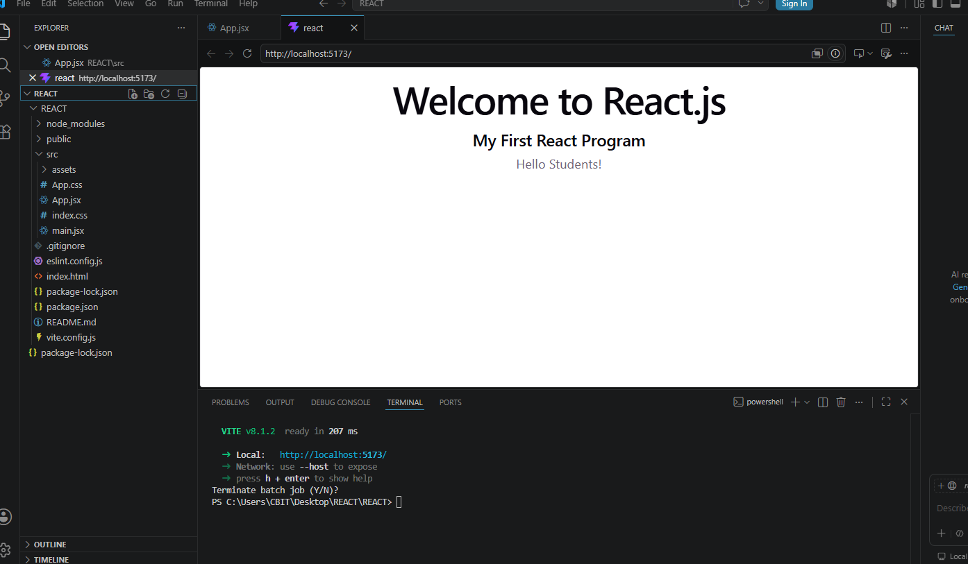
Welcome to React.js
My First React Application
Hello Students!

Step 18: Stop the Server
Press
Ctrl + C
in the terminal.

Running the Project Again
The next time you use the same project:
Open VS Code.
Go to the project folder:
cd my-react-app
Start the server:
npm run dev
Open the URL displayed in the terminal.
You do not need to run npm install again unless you delete the node_modules folder or create a new project.

Useful Commands
Command | Purpose
node -v | Check Node.js version
npm -v | Check npm version
npm create vite@latest | Create a new React project
cd my-react-app | Enter the project folder
npm install | Install project dependencies
npm run dev | Start the React development server
Ctrl + C | Stop the development server

Common Errors and Solutions

Error: npm is not recognized
Cause: Node.js is not installed or not added to the system PATH.
Solution: Install the latest LTS version of Node.js and restart your computer.

Error: ERR_CONNECTION_REFUSED
Cause: The React development server is not running.
Solution:
npm run dev
Then open the URL shown in the terminal.

Error: Port already in use
Cause: Another application is using the default port.
Solution: Vite automatically selects another port (for example, 5174 or 5175). Open the new URL displayed in the terminal.

Error: Cannot find module
Solution:

Npm.cmd install

PS C:\Users\CBIT\Desktop\getexpress> npm.cmd create vite@latest my-react-app
Need to install the following packages:
create-vite@9.1.1
Ok to proceed? (y) y

> getexpress@1.0.0 npx
> create-vite my-react-app

│
◇ Select a framework:
│ React
│
◇ Select a variant:
│ JavaScript
│
◇ Which linter to use?
│ ESLint
│
◇ Install with npm and start now?
│ Yes
│
◇ Scaffolding project in C:\Users\CBIT\Desktop\getexpress\my-react-app...
│
◇ Installing dependencies with npm...

added 135 packages, and audited 136 packages in 58s

31 packages are looking for funding
run `npm fund` for details

found 0 vulnerabilities
│
◇ Starting dev server...

> my-react-app@0.0.0 dev
> vite

VITE v8.1.2 ready in 399 ms

➜ Local: http://localhost:5173/
➜ Network: use --host to expose
➜ press h + enter to show help

PS C:\Users\CBIT\Desktop\REACT> CD REACT
up to date, audited 136 packages in 915ms

31 packages are looking for funding
run `npm fund` for details

found 0 vulnerabilities
PS C:\Users\CBIT\Desktop\REACT\REACT> npm.cmd run dev

> react@0.0.0 dev
> vite

VITE v8.1.2 ready in 207 ms

➜ Local: http://localhost:5173/
➜ Network: use --host to expose
➜ press h + enter to show help
Terminate batch job (Y/N)?
PS C:\Users\CBIT\Desktop\REACT\REACT>
CREATE A NEW PROJECT “COMPONENT “ BY following above steps open “visual studio” click on open folder ,select the folder “COMPONENT” RUN THE BELOW COMMANDS MENTIONED IN VISUAL CODE BY NAVIGATING
TERMINAL ----NEW TERMINAL
APP.JSX
function App() {

return (
<div>
<h1>Welcome to React</h1>
<h2>This is my first Functional Component</h2>
</div>
);

}

export default App;
press ctrlc to get the terminal console again

PS C:\Users\CBIT\Desktop\component> cd component
PS C:\Users\CBIT\Desktop\component\component> npm.cmd install

up to date, audited 136 packages in 949ms

31 packages are looking for funding
run `npm fund` for details

found 0 vulnerabilities
PS C:\Users\CBIT\Desktop\component\component> npm.cmd run dev

> component@0.0.0 dev
> vite

VITE v8.1.2 ready in 212 ms

➜ Local: http://localhost:5173/
➜ Network: use --host to expose
➜ press h + enter to show help
CHANGE THE APP.JSX FILE

function App() {

const college = "CBIT";
const course = "React JS";

return (
<div>
<h1>{college}</h1>
<h2>{course}</h2>
</div>
);

}

export default App;
press ctrlc to get the terminal console again

OPEN NEW TERMINAL IN VISUAL STUDIO
TYPE THE FOLLOWING COMMANDS
NOTE: IAM REPLACING THE APP.JSX ONLY PROJECT IS SAME

PS C:\Users\CBIT\Desktop\component> CD component
PS C:\Users\CBIT\Desktop\component\component> npm.cmd install

up to date, audited 136 packages in 1s

31 packages are looking for funding
run `npm fund` for details

found 0 vulnerabilities
PS C:\Users\CBIT\Desktop\component\component> npm.cmd run dev

> component@0.0.0 dev
> vite

Port 5173 is in use, trying another one...

VITE v8.1.2 ready in 223 ms

➜ Local: http://localhost:5174/
➜ Network: use --host to expose
➜ press h + enter to show help

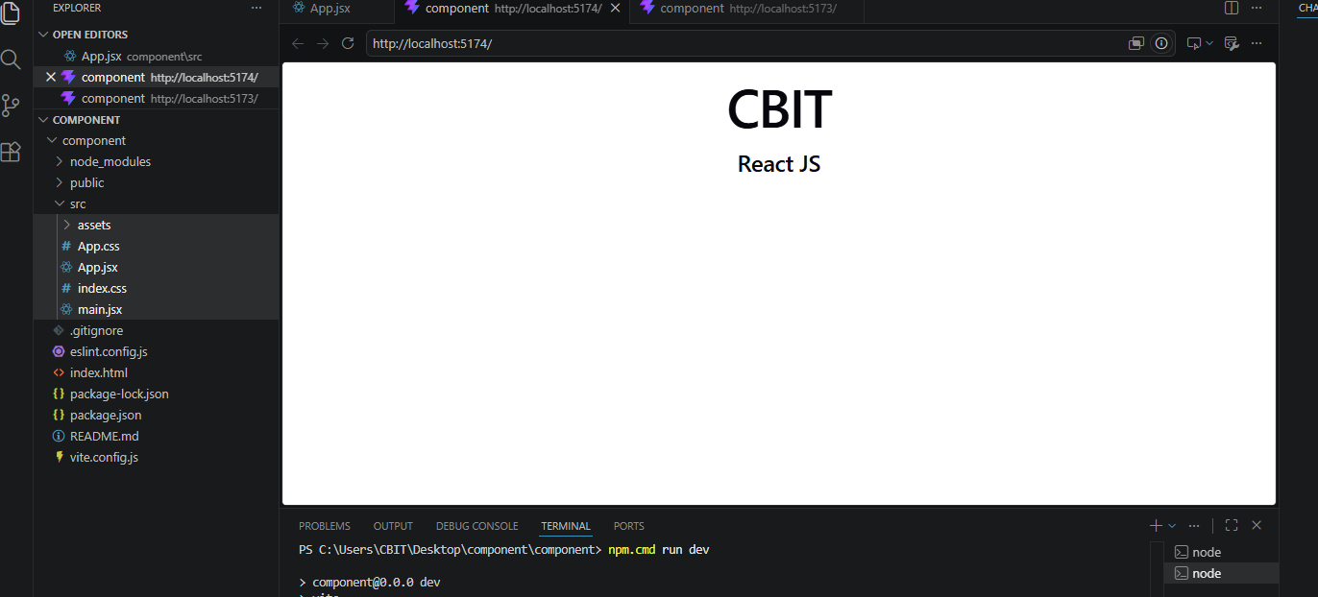

Functional Component with Multiple Variables

function App() {

const name = "Rahul";
const age = 20;
const city = "Hyderabad";

return (
<div>
<h2>Student Details</h2>

<p>Name : {name}</p>

<p>Age : {age}</p>

<p>City : {city}</p>

</div>
);

}

export default App;
run this commands in terminal again
PS C:\Users\CBIT\Desktop\component\component> npm.cmd run dev

> component@0.0.0 dev
> vite

Port 5173 is in use, trying another one...

VITE v8.1.2 ready in 1999 ms

➜ Local: http://localhost:5174/

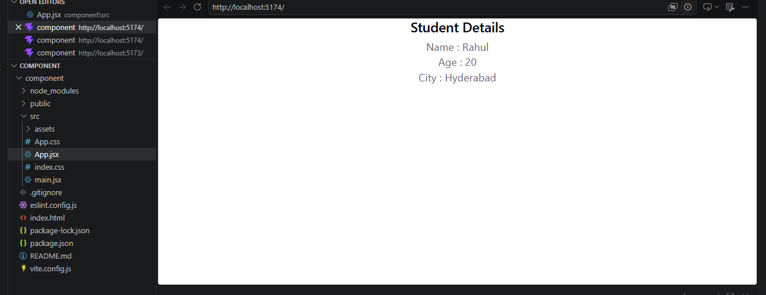

Creating another Functional Component
function Student() {

return (
<h2>Welcome Student</h2>
);

}

function App() {

return (
<div>

<h1>React Components</h1>

<Student />

</div>
);

}

export default App;

run this commands in terminal again
PS C:\Users\CBIT\Desktop\component\component> npm.cmd run dev

> component@0.0.0 dev
> vite

Port 5173 is in use, trying another one...

VITE v8.1.2 ready in 1999 ms

➜ Local: http://localhost:5174/
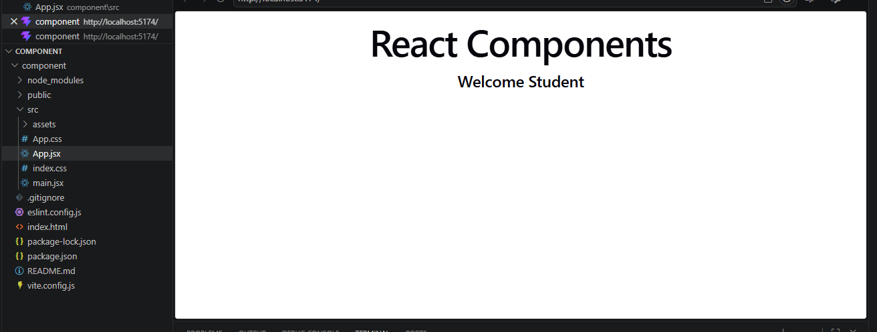

Multiple Functional Components

function Header() {
return <h1>Header Component</h1>;
}

function Content() {
return <h2>Content Component</h2>;
}

function Footer() {
return <h3>Footer Component</h3>;
}

function App() {

return (
<div>

<Header />

<Content />

<Footer />

</div>
);

}

export default App;

press ctrlc to get the terminal console again

Creating Separate Component Files

Folder Structure
src
│
├── App.jsx
├── Header.jsx
├── Footer.jsx
├── Student.jsx

Header.jsx
function Header() {
return (
<h1>Welcome to React</h1>
);
}
export default Header;

Student.jsx
function Student() {
return (
<h2>Second Year B.Tech</h2>
);
}
export default Student;

Footer.jsx
function Footer() {
return (
<h3>Thank You</h3>
);
}
export default Footer;

App.jsx
import Header from "./Header";
import Student from "./Student";
import Footer from "./Footer";
function App() {
return (
<div>
<Header />
<Student />
<Footer />
</div>
);
}
export default App;

Output
Welcome to React
Second Year B.Tech
Thank You

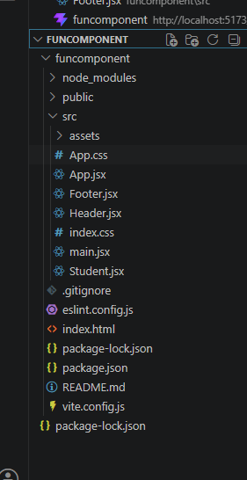

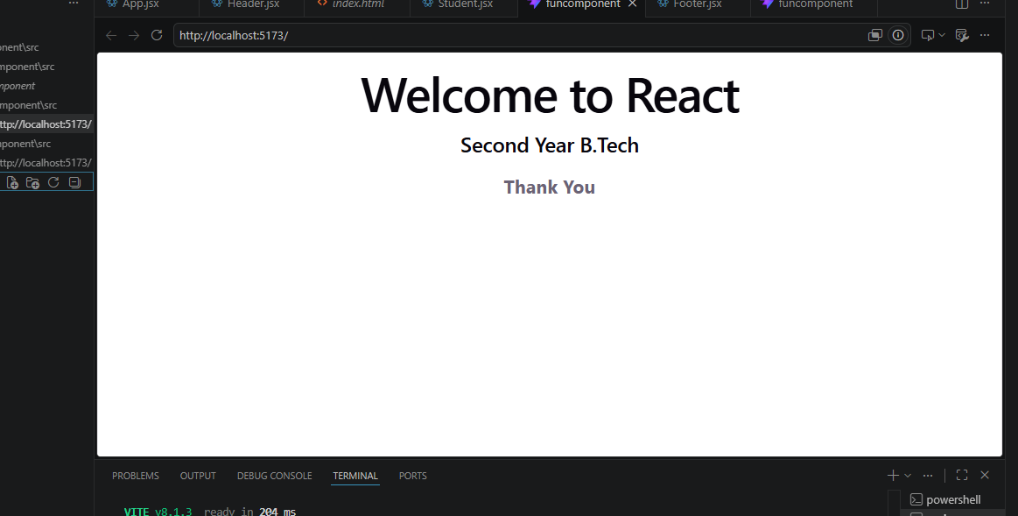

Functional Component Using Arrow Function
App.jsx

const App = () => {

return (

<div>

<h1>Arrow Function Component</h1>

</div>

);

};

export default App;

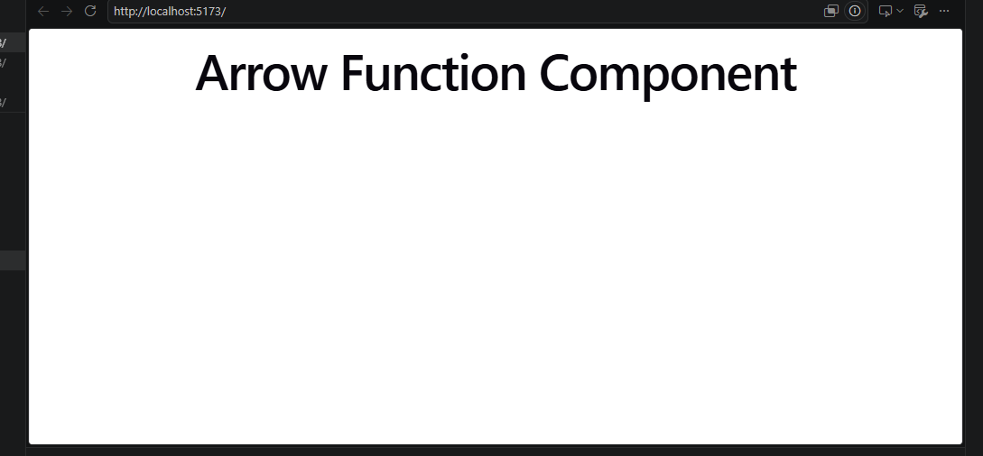

Nested Functional Components
function College() {
return <h2>CBIT</h2>;
}
function Student() {
return (
<div>
<College />
<h3>FALAK</h3>
</div>
);
}
function App() {
return (
<Student />
);
}
export default App;

Output
CBIT
FALAK

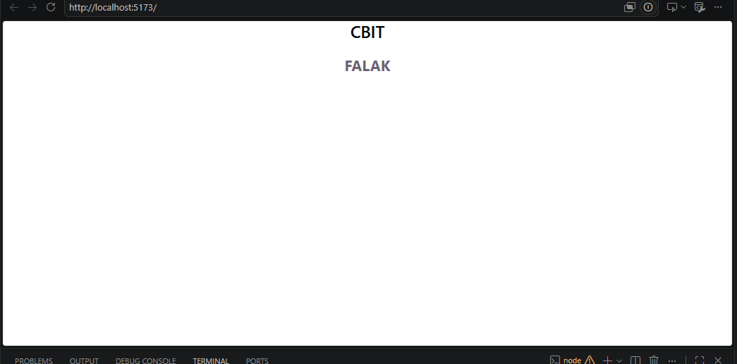

Flow Diagram
App Component
│
▼
Calls Header
│
▼
Calls Student
│
▼
Calls Footer
│
▼
Browser Output

Advantages of Functional Components
Easy to create.
Less code than class components.
Reusable.
Supports Hooks.
Better performance.
Easy to maintain.

Difference Between Functional and Class Components
Functional Component | Class Component
JavaScript function | JavaScript class
Easy to write | More code
Uses Hooks | Uses lifecycle methods
Recommended in modern React | Older approach
Lightweight | More complex

Actual DOM using HTML & JavaScript

Theory
The Actual DOM is the browser's Document Object Model. When JavaScript changes the DOM, the browser updates the actual HTML elements.

Flow Diagram
HTML Page
│
▼
JavaScript
│
▼
Modify DOM
│
▼
Browser Repaints Entire Changed Section

<!DOCTYPE html>
<html>

<head>
<title>Actual DOM Example</title>
</head>

<body>

<h2>Actual DOM Example</h2>

<div id="displayTime"></div>

<script>

function updateTime() {

let element = "";

element += "<h1>Welcome to CBIT</h1>";

element += "<h2>Current Time</h2>";

element += "<h3>" + new Date().toLocaleTimeString() + "</h3>";

document.getElementById("displayTime").innerHTML = element;

}

updateTime();

setInterval(updateTime,1000);

</script>

</body>

</html>

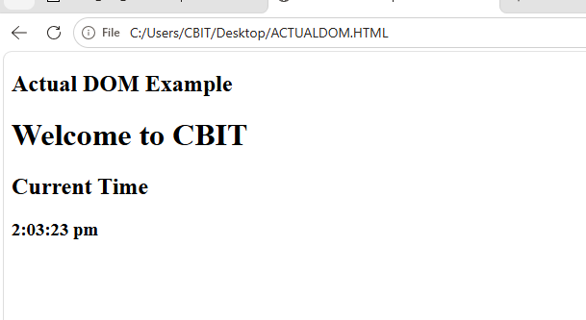

What happens internally?
Every Second
↓
JavaScript creates HTML
↓
innerHTML replaces DOM
↓
Browser redraws page
The DOM is modified directly.

\ Program 2: Virtual DOM (Basic React)

Theory
React creates a Virtual DOM, which is a lightweight copy of the Actual DOM.
React compares
Old Virtual DOM
with
New Virtual DOM
Only the changed element is updated.

Flow Diagram
React Component
↓
Virtual DOM
↓
Compare Previous DOM
↓
Find Difference
↓
Update Browser

App.jsx
function App() {
return (
<div>
<h1>Welcome to CBIT</h1>
<h2>Current Time</h2>
<h3>{new Date().toLocaleTimeString()}</h3>
</div>
);
}
export default App;

main.jsx
import React from "react";
import ReactDOM from "react-dom/client";
import App from "./App";
const root = ReactDOM.createRoot(document.getElementById("root"));
function renderTime(){
root.render(<App/>);
}
renderTime();
setInterval(renderTime,1000);

Run
npm run dev
Open
http://localhost:5173

Output
Welcome to CBIT
Current Time
10:45:12 AM

What happens?
Every Second
↓
New Virtual DOM
↓
Compare Old Virtual DOM
↓
Only Time Updated
↓
Browser Updated
No direct DOM manipulation.

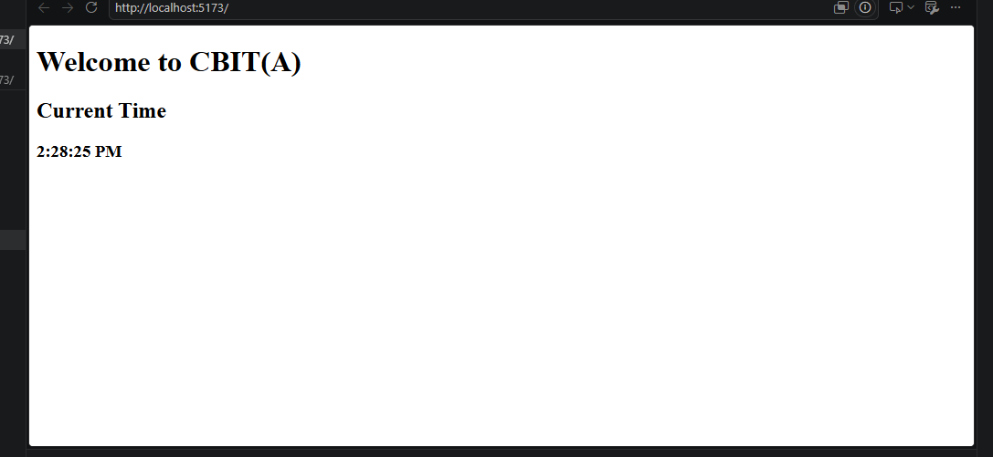

Use this complete App.jsx code
Open src/App.jsx and replace everything with:
import { useState } from "react";
function App() {
const [count, setCount] = useState(0);
console.log("Component Rendered");
return (
<div style={{ textAlign: "center", marginTop: "50px" }}>
<h1>Virtual DOM Example</h1>
<h2>Count: {count}</h2>
<button onClick={() => setCount(count + 1)}>
Increment
</button>
</div>
);
}
export default App;

Output
You should see:
Virtual DOM Example
Count: 0
[ Increment ]
Clicking Increment changes:
Count: 1
Count: 2
Count: 3
.

Actual DOM Example with Increment Button
Save this file as actualdom.html.
<!DOCTYPE html>
<html>
<head>
<title>Actual DOM - Counter Example</title>
<style>
body {
font-family: Arial;
text-align: center;
margin-top: 100px;
}
button {
padding: 10px 20px;
font-size: 18px;
cursor: pointer;
}
h2 {
color: blue;
}
</style>
</head>
<body>
<h1>Actual DOM Example</h1>
<h2 id="count">0</h2>
<button onclick="increment()">Increment</button>
<script>
// Variable to store count
let count = 0;
// Function to increment count
function increment() {
count++;
// Directly updating the Actual DOM
document.getElementById("count").innerHTML = count;
console.log("Actual DOM Updated");
}
</script>
</body>
</html>

Output
Initially:
Actual DOM Example
0
[ Increment ]
After clicking the button once:
Actual DOM Example
1
[ Increment ]
After clicking again:
Actual DOM Example
2
[ Increment ]

How to Execute

Step 1
Open Visual Studio Code.

Step 2
Create a file named:
actualdom.html

Step 3
Paste the above code.

Step 4
Save the file.

Step 5
Right-click the file and select:
Open with Live Server
(or simply double-click the HTML file to open it in a browser).

How It Works
User Clicks Increment Button
│
▼
JavaScript Function increment()
│
▼
count = count + 1
│
▼
document.getElementById("count")
│
▼
innerHTML = count
│
▼
Browser Updates the Actual DOM

In this program, every time the user clicks Increment:
JavaScript directly accesses the DOM using:
document.getElementById("count")
It changes the HTML content using:
innerHTML
The browser immediately updates the displayed value.
This is called Actual DOM manipulation because JavaScript directly modifies the browser's DOM.
import { useState } from "react";

function App() {

const [count, setCount] = useState(0);

console.log("Component Rendered");

return (
<div style={{ textAlign: "center", marginTop: "50px" }}>
<h1>Virtual DOM Example</h1>

<h2>Count: {count}</h2>

<button onClick={() => setCount(count + 1)}>
Increment
</button>
</div>
);
}

export default App;

VIRTUAL DOM
import { useState } from "react";

function App() {

const [count, setCount] = useState(0);

console.log("Component Rendered");

return (
<div style={{ textAlign: "center", marginTop: "50px" }}>
<h1>Virtual DOM Example</h1>

<h2>Count: {count}</h2>

<button onClick={() => setCount(count + 1)}>
Increment
</button>
</div>
);
}

export default App;
Instead of just showing the counter, open the browser's Developer Tools:
- Open the HTML page.
- Press F12.
- Go to the Elements tab.
- Click Increment.
Then open the React page:
- Press F12.
- Click Increment.

In JavaScript, you modify the DOM using document.getElementById().
In React, you never touch the DOM. You update the state (setCount()), and React updates the DOM for you using the Virtual DOM.

import React, { useState } from "react";

function App() {
const [count, setCount] = useState(0);

return (
<div>
<h1>Hello Students</h1>

<p>Count: {count}</p>

<button onClick={() => setCount(count + 1)}>
Increment
</button>
</div>
);
}

export default App;

- Now connect the code to your diagram:
VIRTUAL DOM

State Change
↓
setCount(count + 1)
↓
New Virtual DOM
↓
React creates a new UI representation
↓
Compare with Old Virtual DOM
↓
React's reconciliation process
↓
Find Changes
↓
"Count: 0" → "Count: 1"
↓
Update Actual DOM
↓
<p>Count: 1</p>
↓
UI/Screen

- Explain each line
1. State
const [count, setCount] = useState(0);

- Initial state is:
count = 0

- 2. User clicks the button
<button onClick={() => setCount(count + 1)}>

- setCount() changes the state:
0 → 1

- 3. React creates a new Virtual DOM representation
The previous UI was conceptually:
<p>Count: 0</p>

- The new UI is:
<p>Count: 1</p>

- 4. React compares the previous and new representations
Old: <p>Count: 0</p>
New: <p>Count: 1</p>

- React determines that the relevant text needs to change.
5. Actual DOM is updated
Conceptually, the browser DOM changes from:
<p>Count: 0</p>

- to:
<p>Count: 1</p>

- 6. User sees
Hello Students

Count: 1

[ Increment ]

- One important teaching point
Don't tell students that React literally does:
Virtual DOM → compare every HTML element → update only one element

- as if that's the exact internal implementation.
For teaching, you can say:
“React creates a new Virtual DOM representation, compares it with the previous one during reconciliation, determines the necessary DOM changes, and commits those changes to the Actual DOM.”
That is more technically accurate.
Very simple code for classroom demonstration
If you want to demonstrate the Actual DOM vs Virtual DOM difference side-by-side, you can use:
// Actual DOM manipulation
document.getElementById("count").innerText = 1;

- versus React:
const [count, setCount] = useState(0);

<button onClick={() => setCount(count + 1)}>
Increment
</button>

<p>{count}</p>

- This makes the distinction very clear:
JavaScript React

getElementById() setCount()
↓ ↓
Actual DOM directly State change
↓
React reconciliation
↓
Actual DOM update

You said:
- reconciliation

ChatGPT said:
- What is Reconciliation in React?
For 3rd-year students, explain reconciliation as:
Reconciliation is the process React uses to compare the previous Virtual DOM with the new Virtual DOM and determine what changes need to be made to the Actual DOM.
Simple flow
State changes
↓
New Virtual DOM
↓
Reconciliation
↓
Compare old Virtual DOM
with new Virtual DOM
↓
Identify changes
↓
Update Actual DOM
↓
Browser UI

- Simple example
Suppose initially we have:
<p>Count: 0</p>

- After clicking a button:
<p>Count: 1</p>

- React conceptually has:
OLD Virtual DOM NEW Virtual DOM

<p>Count: 0</p> → <p>Count: 1</p>

- During reconciliation, React determines:
"Count: 0" → "Count: 1"

- So the necessary DOM update is made.
Code Example
import { useState } from "react";

function Counter() {
const [count, setCount] = useState(0);

return (
<div>
<h1>Counter</h1>

<p>Count: {count}</p>

<button onClick={() => setCount(count + 1)}>
Increment
</button>
</div>
);
}

export default Counter;

- When the button is clicked:
setCount(count + 1);

- What happens?
1. State changes
↓
count: 0 → 1

2. React renders again
↓

3. New Virtual DOM is created
↓

4. Reconciliation
↓
Old: <p>Count: 0</p>
New: <p>Count: 1</p>

5. React determines what changed
↓

6. Actual DOM is updated
↓

<p>Count: 1</p>

- 7. Browser displays the result

Introduction
React applications are built using components. Every component may contain data that needs to be displayed or updated.
React provides two important concepts to manage this data:
- State
- Props (Properties)
These are the foundation of React applications.

Data Flow in React
React Application
│
--------------------
│ │
State Props
│ │
▼ ▼
Current Component Child Component

What is State?

Definition
State is a built-in object that stores data belonging to a component. This data can change over time, and whenever it changes, React automatically updates the user interface.

Key Points
State is local to a component.
State is mutable (can change).
Updating state re-renders the component.
State is created using the useState() hook.

Real-Life Example
Consider a mobile phone.
Battery percentage
Wi-Fi status
Brightness level
Volume
These values change frequently. They represent State.

Characteristics of State
Local to a component
Stores dynamic data
Can be modified
Automatically updates the UI
Managed using Hooks

Syntax of State
const [stateVariable, setStateVariable] = useState(initialValue);
Example:
const [count, setCount] = useState(0);
Where:
count → current value
setCount() → updates the value
0 → initial value

State Flow Diagram
Button Click
│
▼
setState()
│
▼
State Changes
│
▼
React Re-renders Component
│
▼
Browser Displays Updated Data

Example 1: Counter Using State

App.jsx
import { useState } from "react";
function App() {
const [count, setCount] = useState(0);
return (
<div style={{textAlign:"center"}}>
<h1>Counter Application</h1>
<h2>{count}</h2>
<button onClick={() => setCount(count + 1)}>
Increment
</button>
</div>
);
}
export default App;

Output
Counter Application
0
[Increment]
After clicking:
1


EXAMPLE -2

Step 1: Create a Vite React Project

Open the terminal in VS Code and run:
npm.cmd create vite@latest my-react-app
Choose:
Framework: React
Variant: JavaScript

Step 2: Go to the Project Folder
cd my-react-app

Step 3: Install Dependencies
npm.cmd install

Step 4: Open the Project
code .

Step 5: Replace App.jsx
Open:
my-react-app
│
└── src
└── App.jsx
Delete everything and paste your React code.
Example:
import { useState } from "react";

function App() {
const [count, setCount] = useState(0);

return (
<div style={{ textAlign: "center", marginTop: "50px" }}>
<h1>Counter App</h1>

<h2>{count}</h2>

<button onClick={() => setCount(count + 1)}>
Increment
</button>

<button onClick={() => setCount(count - 1)}>
Decrement
</button>

<button onClick={() => setCount(0)}>
Reset
</button>
</div>
);
}

export default App;

Step 6: Check main.jsx
Open:
src/main.jsx
It should look like this:
import React from "react";
import ReactDOM from "react-dom/client";
import App from "./App.jsx";
import "./index.css";

ReactDOM.createRoot(document.getElementById("root")).render(
<React.StrictMode>
<App />
</React.StrictMode>
);

Step 7: Run the Project
In the terminal, run:
npm run dev
You will see output similar to:
VITE v7.x.x ready in 500 ms

➜ Local: http://localhost:5173/
➜ Network: http://192.168.1.5:5173/

Step 8: Open the Browser
Open:
http://localhost:5173/
You will see:
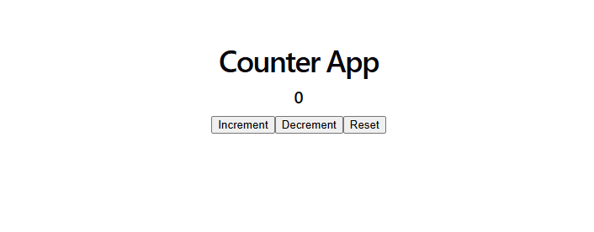
Counter App

0

[Increment] [Decrement] [Reset]

Folder Structure
my-react-app
│
├── node_modules
├── public
├── src
│ ├── App.jsx
│ ├── main.jsx
│ ├── index.css
│ └── assets
├── package.json
├── vite.config.js
└── ...

Commands Summary
npm create vite@latest my-react-app
cd my-react-app
npm install
npm run dev

Example : Change Text using State
import React, { useState } from "react";

function App() {

const [message, setMessage] = useState("Welcome");

return (
<div style={{ textAlign: "center" }}>
<h1>{message}</h1>

<button onClick={() => setMessage("Hello React!")}>
Change Text
</button>
</div>
);
}

export default App;


after click on change text



Example : Show/Hide Text
import React, { useState } from "react";

function App() {

const [show, setShow] = useState(true);

return (
<div style={{ textAlign: "center" }}>

<button onClick={() => setShow(!show)}>
Toggle
</button>

{show && <h2>React State Example</h2>}

</div>
);
}

export default App;


click on toggle


Example : Input Box using State
import React, { useState } from "react";

function App() {

const [name, setName] = useState("");

return (
<div style={{ textAlign: "center" }}>

<h2>Hello {name}</h2>

<input
type="text"
placeholder="Enter your name"
value={name}
onChange={(e) => setName(e.target.value)}
/>

</div>
);
}

export default App;

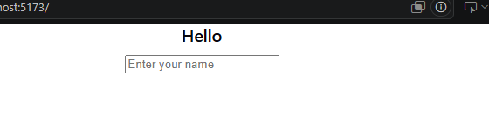
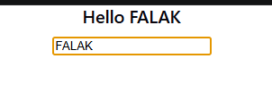

EXAMPLE -ARRAY STATE

app.jsx

import React, { useState } from "react";

function App() {

const [fruits, setFruits] = useState([
"Apple",
"Mango",
"Orange"
]);

const addFruit = () => {
setFruits([...fruits, "Banana"]);
};

return (
<div>

<h2>Fruit List</h2>

<ul>
{fruits.map((fruit, index) => (
<li key={index}>{fruit}</li>
))}
</ul>

<button onClick={addFruit}>
Add Fruit
</button>

</div>
);
}

export default App;

OUTPUT:

OPEN TERMINAL
TYPE npm.cmd run dev


click on add fruit

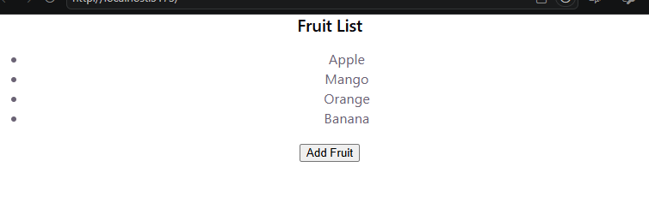

EXAMPLE - STUDENT DETAILS

CHANGE THE CODE OF APP.JSX
import React, { useState } from "react";

function App() {

const [employee] = useState({
id: 101,
name: "John",
designation: "Software Engineer"
});

return (
<div>

<h2>Employee Details</h2>

<p>ID : {employee.id}</p>
<p>Name : {employee.name}</p>
<p>Designation : {employee.designation}</p>

</div>
);
}

export default App;

OUTPUT
TYPE IN TERMINAL
NPM.CMD RUN DEV(WE ARE USING THE EXISTING PROJECT EMP )
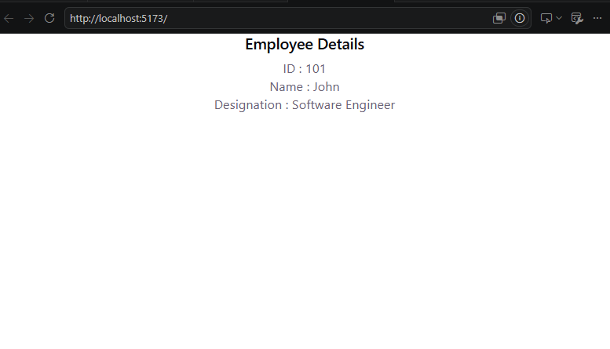
EXAMPLE 4:STUDENT DETAIL FORM
app.jsx

import React, { useState } from "react";

function App() {

const [student, setStudent] = useState({
name: "",
course: ""
});

return (
<div>

<input
type="text"
placeholder="Name"
onChange={(e) =>
setStudent({ ...student, name: e.target.value })
}
/>

<br /><br />

<input
type="text"
placeholder="Course"
onChange={(e) =>
setStudent({ ...student, course: e.target.value })
}
/>

<h3>Name: {student.name}</h3>
<h3>Course: {student.course}</h3>

</div>
);
}

export default App;

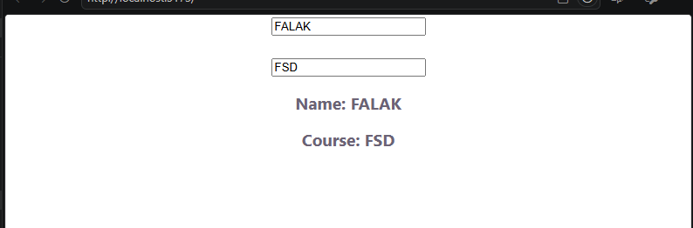

Employee Table with Add Button
app.jsx

import React, { useState } from "react";

function App() {

const [employees, setEmployees] = useState([
{ id: 1, name: "John", designation: "SE" },
{ id: 2, name: "Tom", designation: "SSE" },
{ id: 3, name: "Kevin", designation: "TL" }
]);

const addEmployee = () => {
setEmployees([
...employees,
{
id: 4,
name: "Sam",
designation: "Manager"
}
]);
};

return (
<div>

<table border="1" cellPadding="10">

<thead>
<tr>
<th>ID</th>
<th>Name</th>
<th>Designation</th>
</tr>
</thead>

<tbody>
{employees.map((emp) => (
<tr key={emp.id}>
<td>{emp.id}</td>
<td>{emp.name}</td>
<td>{emp.designation}</td>
</tr>
))}
</tbody>

</table>

<br />

<button onClick={addEmployee}>
Add Employee
</button>

</div>
);
}

export default App;

useState Syntax
const [state, setState] = useState(initialValue);
- state → Stores the current value.
- setState → Updates the value.
- initialValue → The initial state (number, string, array, object, etc.).

OUTPUT
TYPE IN TERMINAL
npm.cmd run dev (using existing project emp so no need to type npm.cmd install)
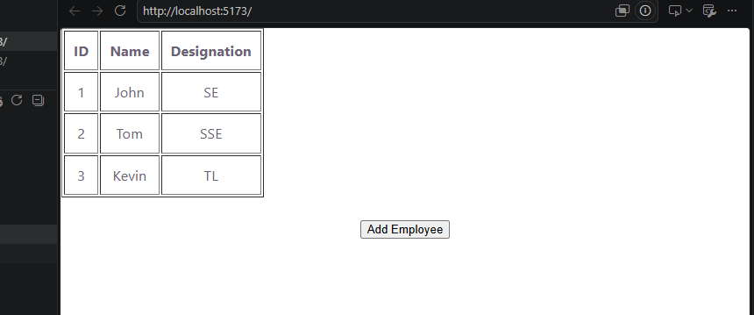

AFTER CLICKING ON
‘Add Employee” button

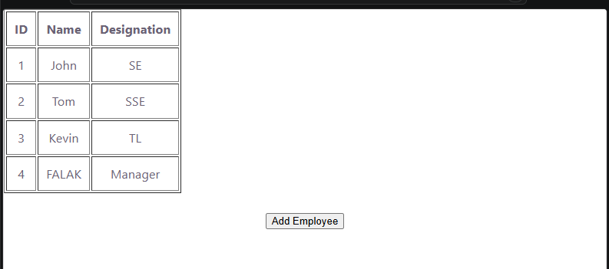

What are Props?

Definition
Props (Properties) are used to pass data from a Parent Component to a Child Component.
Props make components reusable.

Characteristics of Props
- Read-only
- Passed from parent to child
- Child cannot modify props
- Used for communication between components

Real-Life Example
Teacher writes marks on a report card.
Student receives them.
The student cannot change them.
Teacher → Parent Component
Marks → Props
Student → Child Component

Props Flow Diagram
Parent Component
│
Passes Props
│
▼
Child Component
│
Displays Data

Syntax

Parent Component
<Student name="Rahul" age="20" />

Child Component
function Student(props){
return(
<h2>{props.name}</h2>
);
}

Example 2: Props Example

Student.jsx
function Student(props){
return(
<div>
<h2>Name : {props.name}</h2>
<h2>Age : {props.age}</h2>
<h2>College : {props.college}</h2>
</div>
);
}
export default Student;

App.jsx
import Student from "./Student";
function App(){
return(
<div>
<Student
name="DEEPAK"
age="20"
college="CBIT"
/>
</div>
);
}
export default App;

Output

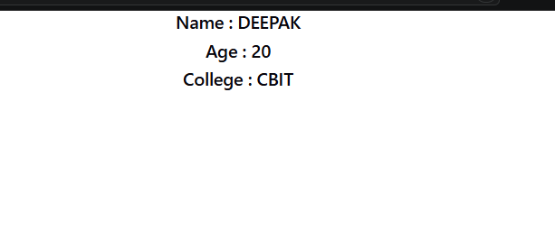
Name : Rahul
Age : 20
College : CBIT

Example 3: Reusable Component

App.jsx
import Student from "./Student";
function App(){
return(
<div>
<Student
name="Rahul"
age="20"
college="CBIT"
/>
<Student
name="Priya"
age="19"
college="MGIT"
/>
</div>
);
}
export default App;

Output

type in terminal

npm.cmd run dev

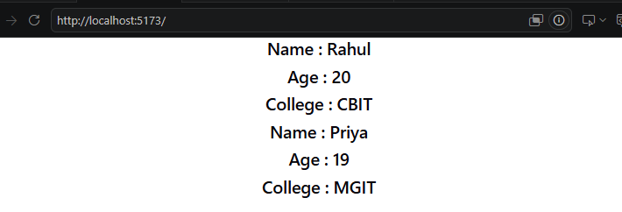
Name : Rahul
Age : 20
College : CBIT
Name : Priya
Age : 19
College : MGIT

State vs Props
State | Props
Stores data inside a component | Passes data from parent to child
Mutable (can change) | Immutable (read-only)
Managed by the component | Passed by the parent
Uses useState() | Uses JSX attributes
Triggers re-render when updated | Does not change in the child

State vs Props Diagram
React Component
┌─────────────────────┐
│ State │
│ Own Data │
│ Can Change │
└─────────┬───────────┘
│
Re-render UI
│
▼
--------------------------------------------
Parent Component
│
│ Passes Props
▼
Child Component
Receives Data Only

State vs Props Example

Using State
const [name, setName] = useState("Rahul");
The component can change the value:
setName("Amit");

Using Props
Parent Component
<Student name="Rahul"/>
Child Component
function Student(props){
return <h2>{props.name}</h2>;
}
The child component cannot change props.name.

When to Use State?
Use State when:
- Counter
- Calculator
- Login Form
- Shopping Cart
- Todo List
- Online Quiz
- Timer
- Digital Clock

When to Use Props?
Use Props when:
- Student Details
- Employee Information
- Product Details
- User Profile
- Displaying Data
- Parent-to-Child Communication

Advantages of State
- Stores dynamic data
- Updates the UI automatically
- Makes applications interactive
- Easy to manage using Hooks

Advantages of Props
- Makes components reusable
- Enables parent-child communication
- Improves code readability
- Encourages modular design
this is a Props with Destructuring example. Here's how to execute it step by step.

Step 1: Open Your React Project
Open your React project in VS Code.
Example:
my-react-app

Step 2: Create Greeting.jsx
Inside the src folder, create a new file named:
Greeting.jsx
Paste the following code:
const Greeting = ({ name }) => {
return (
<h2>Welcome, {name}!</h2>
);
};

export default Greeting;

Explanation
({ name })
is called object destructuring.
Instead of writing:
function Greeting(props) {
return <h2>Welcome, {props.name}!</h2>;
}
we directly write:
function Greeting({ name }) {
return <h2>Welcome, {name}!</h2>;
}
Both are equivalent.

Step 3: Open App.jsx
Replace the existing code with:
import Greeting from "./Greeting";

function App() {

return (

<div>

<h1>Props using Destructuring</h1>

<Greeting name="Lakshmi" />

<Greeting name="React Student" />

</div>

);

}

export default App;

Step 4: Folder Structure
Your project should look like this:
my-react-app
│
├── src
│ ├── App.jsx
│ ├── Greeting.jsx
│ ├── main.jsx
│
├── package.json
├── index.html

Step 5: Start the React Server
Open the terminal in VS Code.
Run:
npm run dev

Step 6: Open the Browser
Go to:
http://localhost:5173

Output
Props using Destructuring

Welcome, Lakshmi!

Welcome, React Student!

Data Flow
App.jsx (Parent)

<Greeting name="Lakshmi"/>

│
Passes Props
│
▼

Greeting.jsx (Child)

const Greeting = ({name})

│
▼

Welcome, Lakshmi!

Interview Question

What is Destructuring in React?
Answer:
Destructuring is a JavaScript feature used to extract values from an object or array. In React, it is commonly used to directly access props without writing props.propertyName.
Without destructuring:
function Greeting(props) {
return <h2>{props.name}</h2>;
}
With destructuring:
function Greeting({ name }) {
return <h2>{name}</h2>;
}
Both produce the same output, but destructuring makes the code shorter, cleaner, and easier to read.

React Hooks (useState and useEffect)

Learning Objectives
After completing this topic, students will be able to:
- Understand React Hooks.
- Explain the useState Hook.
- Explain the useEffect Hook.
- Create interactive React applications using Hooks.
- Differentiate between useState and useEffect.

What are React Hooks?

Definition
Hooks are special functions introduced in React 16.8 that allow functional components to use React features such as state and lifecycle methods without writing class components.

Common Hooks
- useState()
- useEffect()
- useContext()
- useRef()
- useMemo()
- useCallback()
The two most commonly used hooks are:
- useState()
- useEffect()

useState() Hook

Definition
The useState() Hook is used to create and manage state in a functional component.
Whenever the state changes, React automatically updates the user interface.

Syntax
const [state, setState] = useState(initialValue);

Explanation
- state → Current value
- setState → Function to update the value
- initialValue → Initial state value

Flow Diagram
User Click
│
▼
setState()
│
▼
State Updated
│
▼
Component Re-renders
│
▼
Updated UI

Example 1: Counter using useState

App.jsx
import { useState } from "react";

function App() {

const [count, setCount] = useState(0);

return (
<div style={{ textAlign: "center" }}>
<h1>Counter Application</h1>

<h2>{count}</h2>

<button onClick={() => setCount(count + 1)}>
Increment
</button>
</div>
);
}

export default App;

Output
Counter Application
0 [Increment]
After clicking:
1
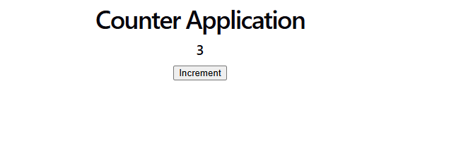Example 2: Toggle Button
import { useState } from "react";

function App() {

const [status, setStatus] = useState("OFF");

return (
<div>

<h2>Switch is {status}</h2>

<button
onClick={() =>
setStatus(status === "OFF" ? "ON" : "OFF")
}
>
Toggle
</button>

</div>
);
}

export default App;


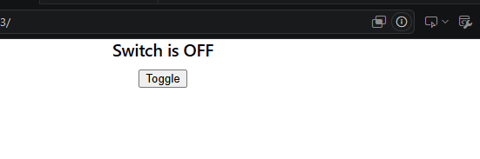

useEffect() Hook

Definition
The useEffect() Hook is used to perform side effects in React components.

Side Effects include:
- Fetching data from an API
- Updating the document title
- Timers
- Event listeners
- Reading browser storage

Syntax
useEffect(() => {

// Code

}, []);

Flow Diagram
Component Loads
│
▼
useEffect()
│
▼
Execute Side Effect

What is a Hook?
A Hook is a special function in React that allows functional components to use React features such as state and lifecycle methods.
The most commonly used Hook is:
useState()

What is useState()?

Definition
The useState() Hook is used to create and manage state (data) in a functional component.
Whenever the state changes, React automatically updates the user interface (UI).

Why do we use useState()?
Without useState(), the values displayed in a component cannot change dynamically.
Using useState() allows us to:
- Store data
- Update data
- Automatically refresh the UI

Syntax
const [stateVariable, setStateVariable] = useState(initialValue);

Explanation
Part | Description
stateVariable | Stores the current value
setStateVariable | Updates the state value
useState() | React Hook used to create state
initialValue | Initial value of the state

Flow Diagram
Component Loads
│
▼
Create State
│
▼
Display State
│
▼
User Clicks Button
│
▼
setState()
│
▼
State Updated
│
▼
React Re-renders Component
│
▼
Updated UI Displayed

Example 3: Welcome Message
import { useEffect } from "react";

function App() {

useEffect(() => {

alert("Welcome to React!");

}, []);

return <h1>Hello Students</h1>;
}

export default App;

Output
When the page loads:
Welcome to React!
Then:
Hello Students
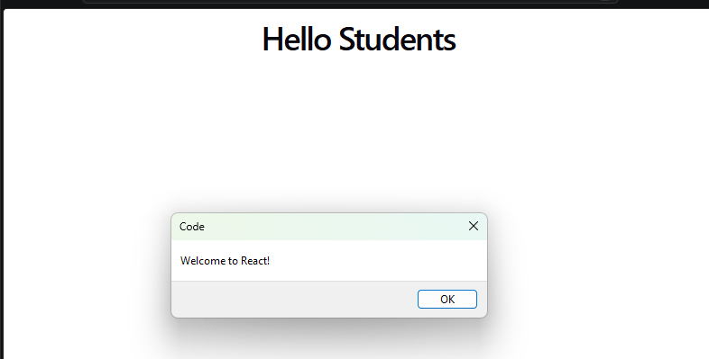

Example 4: Digital Clock using useEffect
import { useState, useEffect } from "react";

function App() {

const [time, setTime] = useState(new Date());

useEffect(() => {

const timer = setInterval(() => {

setTime(new Date());

}, 1000);

return () => clearInterval(timer);

}, []);

return (

<div>

<h1>Digital Clock</h1>

<h2>{time.toLocaleTimeString()}</h2>

</div>

);
}

export default App;

Output
Digital Clock

10:45:20 AM
Updates every second.

Difference between useState and useEffect
useState() | useEffect()
Stores data | Performs side effects
Changes component state | Executes code after rendering
Causes re-render | Does not store data
Returns state and updater function | Takes a callback function

Real-Life Example

useState
A classroom attendance count:
Present Students = 45

↓

One student enters

↓

Present Students = 46
The count changes.

useEffect
When a classroom starts:
Class Starts

↓

Attendance Taken

↓

Projector Turned On

↓

Announcements Displayed
These actions happen after the class starts, similar to side effects after rendering.

Applications

useState
- Counter
- Calculator
- Login Form
- Shopping Cart
- Todo List

useEffect
- API Calls
- Digital Clock
- Weather App
- Online News Feed
- Document Title Updates

What is React Router?

Definition
React Router is a library used to navigate between different pages (components) in a React application without refreshing the browser.
It enables Single Page Application (SPA) navigation.

Why Do We Need React Router?
Without React Router:
- Only one page is displayed.
- Clicking links reloads the browser.
With React Router:
- Multiple pages can be displayed.
- Navigation is faster.
- The page does not reload.

Real-Life Example
Consider a college website.
- Home
- About
- Courses
- Contact
Clicking each menu should display a different page without reloading.
React Router makes this possible.

React Router Flow Diagram
Browser

│

▼

React Router

│

▼

URL Matches Route

│

▼

Required Component Displayed

Features of React Router
- Client-side routing
- Fast navigation
- No page refresh
- Easy to create multiple pages
- Supports dynamic routing

Important Components
Component | Purpose
BrowserRouter | Enables routing
Routes | Contains all routes
Route | Defines a route
Link | Creates navigation links
NavLink | Navigation with active styling
useNavigate | Navigates using JavaScript

Installation
Open Terminal
npm install react-router-dom
Wait until installation completes.

Project Structure
my-react-app

│

├── src

│ ├── App.jsx

│ ├── Home.jsx

│ ├── About.jsx

│ ├── Contact.jsx

│ └── main.jsx

Step 1: Create Home Component

Home.jsx
function Home() {

return (

<h2>Welcome to Home Page</h2>

);

}

export default Home;

Step 2: Create About Component

About.jsx
function About() {

return (

<h2>Welcome to About Page</h2>

);

}

export default About;

Step 3: Create Contact Component

Contact.jsx
function Contact() {

return (

<h2>Welcome to Contact Page</h2>

);

}

export default Contact;
contact.jsx to add content
function Contact() {
return (
<div>
<h2>Contact Page</h2>
<p>Email: cbit@gmail.com</p>
</div>
);
}

export default Contact;

Step 4: Modify App.jsx
import { BrowserRouter, Routes, Route, Link } from "react-router-dom";

import Home from "./Home";
import About from "./About";
import Contact from "./Contact";

function App() {

return (

<BrowserRouter>

<h1>React Router Example</h1>

<nav>

<Link to="/">Home</Link>

{" | "}

<Link to="/about">About</Link>

{" | "}

<Link to="/contact">Contact</Link>

</nav>

<hr />

<Routes>

<Route path="/" element={<Home />} />

<Route path="/about" element={<About />} />

<Route path="/contact" element={<Contact />} />

</Routes>

</BrowserRouter>

);

}

export default App;

Step 5: main.jsx
Keep it as:
import React from "react";
import ReactDOM from "react-dom/client";
import App from "./App";

ReactDOM.createRoot(document.getElementById("root")).render(

<App />

);

Execution Steps

Step 1
Open your React project.

Step 2
Open Terminal.
C:\Users\CBIT\Desktop\reactrouter> npm.cmd create vite@latest

> npx
> create-vite

│
◇ Project name:
│ RROUTER
│
◇ Package name:
│ package.son
│
◇ Select a framework:
│ React
│
◇ Select a variant:
│ JavaScript
│
◇ Which linter to use?
│ ESLint
│
◇ Install with npm and start now?
│ Yes
│
◇ Scaffolding project in C:\Users\CBIT\Desktop\reactrouter\RROUTER...
│
◇ Installing dependencies with npm...

added 135 packages, and audited 136 packages in 1m

31 packages are looking for funding
run `npm fund` for details

found 0 vulnerabilities
│
◇ Starting dev server...

> package.son@0.0.0 dev
> vite
PS C:\Users\CBIT\Desktop\reactrouter\ cd RROUTER

Step 3
Install Router
npm install react-router-dom

Step 4
Run project
npm run dev

Step 5
Open
http://localhost:5173

Output
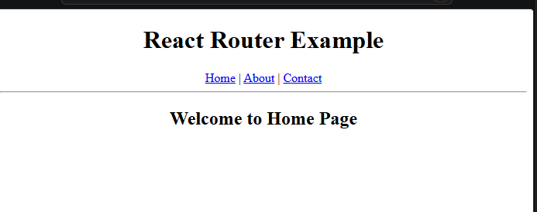

Initially
React Router Example

Home | About | Contact

----------------------

Welcome to Home Page
Click About
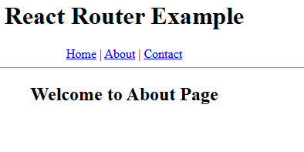
Welcome to About Page
Click Contact
Welcome to Contact Page

Notice that the browser does not refresh.

How React Router Works
User Clicks Link

│

▼

React Router

│

▼

Checks URL

│

▼

Displays Matching Component

BrowserRouter
It enables routing in the application.
<BrowserRouter>

...

</BrowserRouter>

Routes
Contains all routing information.
<Routes>

...

</Routes>

Route
Maps a URL to a component.
<Route path="/about" element={<About />} />
Meaning:
If URL is
/about
display
About Component

Link
Used to navigate between pages.
<Link to="/about">

About

</Link>
Unlike an HTML <a> tag, Link changes the page without reloading the browser.

Applications
React Router is used in:
- College Website
- Hospital Management System
- Banking Application
- Shopping Website
- Employee Management
- Student Portal
- Online Examination System

Advantages
- Faster navigation
- Better user experience
- No browser refresh
- Easy to manage pages
- Supports dynamic routing

ntroduction
A form is used to collect information from users such as:
- Student Registration
- Login
- Online Examination
- Banking Applications
- Shopping Websites
- Employee Registration
Before submitting the data, it is important to verify that the information entered is correct. This process is called Form Validation.

What is Form Validation?

Definition
Form Validation is the process of checking whether the user has entered valid and complete information before submitting the form.
Validation ensures that:
- Required fields are filled.
- Data is entered in the correct format.
- Incorrect information is rejected.
- Only valid data is submitted.

Why is Form Validation Required?
Form validation helps to:
- Prevent empty fields.
- Improve data accuracy.
- Enhance user experience.
- Reduce server errors.
- Improve application security.

Types of Validation

1. Client-Side Validation
Validation is performed in the browser before sending data to the server.
Examples:
- Required field
- Email format
- Password length
Advantages
- Fast response
- Immediate feedback
- Reduces server load

2. Server-Side Validation
Validation is performed on the server after the form is submitted.
Examples:
- Checking whether an email already exists.
- Verifying login credentials.
- Validating database records.

Controlled Components
In React, form elements are usually controlled components.
A controlled component is an input element whose value is controlled by the React state.
Example:
<input
type="text"
value={name}
onChange={handleChange}
/>
React stores the input value in state, making it easier to validate and manage the form.

Flow of Form Validation
User Enters Data
│
▼
Input Stored in State
│
▼
Validation Function Executes
│
▼
Any Errors?
│ │
Yes No
│ │
Show Errors Submit Form

React Hooks Used

useState()
The useState() hook stores:
- Form values
- Error messages
Example:
const [formData, setFormData] = useState({
name:"",
email:"",
password:""
});

Event Handling
React uses events to capture user actions.
Event | Purpose
onChange | Detects input changes
onSubmit | Executes when the form is submitted
onClick | Detects button clicks

Validation Rules
A registration form commonly validates:

Name
- Cannot be empty
- Must contain alphabets

Email
- Cannot be empty
- Must follow email format
Example:
abc@gmail.com

Password
- Minimum 6 characters
- Can include letters, numbers, and symbols

Regular Expression for Email Validation
Example:
/\S+@\S+\.\S+/
This checks whether the email follows the pattern:
username@domain.extension
Example of valid emails:
student@gmail.com

abc@yahoo.com

test@cbit.ac.in

Displaying Error Messages
If validation fails, React displays an error message below the corresponding input field.
Example:
Name is required

Invalid Email

Password must be at least 6 characters
This helps users correct mistakes before submitting the form.

Preventing Form Submission
Normally, clicking the Submit button refreshes the page.
React prevents this using:
event.preventDefault();
This keeps the user on the same page while validation is performed.

Advantages of Form Validation
- Prevents invalid input.
- Improves data quality.
- Reduces server-side errors.
- Enhances security.
- Provides a better user experience.
- Saves processing time.

Real-Time Applications
Form validation is used in:
- Student Registration System
- College Admission Portal
- Banking Applications
- Employee Registration
- Online Shopping
- Railway Reservation
- Hospital Management System
- Online Examination System

Difference Between HTML Validation and React Validation
HTML Validation | React Validation
Uses HTML attributes like required | Uses JavaScript and React state
Limited customization | Highly customizable
Browser-controlled | Developer-controlled
Basic validation | Advanced validation with custom rules

Project Structure
rvalidation
│
├── src
│ ├── App.jsx
│ ├── main.jsx
│ ├── index.css
│
├── index.html
├── package.json

main.jsx
import React from "react";
import ReactDOM from "react-dom/client";
import App from "./App";

ReactDOM.createRoot(document.getElementById("root")).render(
<React.StrictMode>
<App />
</React.StrictMode>
);

App.jsx

import { useState } from "react";

function App() {

const [formData, setFormData] = useState({

name: "",

email: "",

password: ""

});

const [errors, setErrors] = useState({});

// Handle Input Changes

function handleChange(event) {

const { name, value } = event.target;

setFormData({

...formData,

[name]: value

});

}

// Form Validation

function validate() {

let tempErrors = {};

if (formData.name.trim() === "") {

tempErrors.name = "Name is required";

}

if (formData.email.trim() === "") {

tempErrors.email = "Email is required";

}

else if (!/\S+@\S+\.\S+/.test(formData.email)) {

tempErrors.email = "Invalid Email";

}

if (formData.password.length < 6) {

tempErrors.password = "Password must be at least 6 characters";

}

setErrors(tempErrors);

return Object.keys(tempErrors).length === 0;

}

// Submit Form

function handleSubmit(event) {

event.preventDefault();

if (validate()) {

alert("Form Submitted Successfully");

console.log(formData);

}

}

return (

<div style={{width:"400px",margin:"30px auto"}}>

<h2>Student Registration Form</h2>

<form onSubmit={handleSubmit}>

<label>Name</label><br/>

<input

type="text"

name="name"

value={formData.name}

onChange={handleChange}

/>

<br/>

<span style={{color:"red"}}>{errors.name}</span>

<br/><br/>

<label>Email</label><br/>

<input

type="text"

name="email"

value={formData.email}

onChange={handleChange}

/>

<br/>

<span style={{color:"red"}}>{errors.email}</span>

<br/><br/>

<label>Password</label><br/>

<input

type="password"

name="password"

value={formData.password}

onChange={handleChange}

/>

<br/>

<span style={{color:"red"}}>{errors.password}</span>

<br/><br/>

<button type="submit">

Register

</button>

</form>

</div>

);

}

export default App;

Steps to Execute

Step 1
Open your React project in VS Code.

Step 2
Replace App.jsx with the Form Validation code.

Step 3
main.jsx .

Step 4
Open the terminal and run:
npm run dev

Step 5
Open the browser:
http://localhost:5173

If You Don't Have index.css
You have two options:

Option 1 (Recommended)
Create a file named index.css inside the src folder.
Example:
body {
font-family: Arial, sans-serif;
background-color: #f5f5f5;
}

Option 2
If you don't want to use CSS, remove this line from main.jsx:
import "./index.css";
Then your main.jsx becomes:
import React from "react";
import ReactDOM from "react-dom/client";
import App from "./App";

ReactDOM.createRoot(document.getElementById("root")).render(
<React.StrictMode>
<App />
</React.StrictMode>
);

